TECHNICAL GUIDE SPECIFICATIONS | 
VALUSINE
Single Phase, (500 to 2100 Watts)
UL924 Central Lighting Inverter

- SCOPE
The Emergency Lighting Power System shall be a solid-state single phase unit designed to provide regulated and conditioned sinusoidal power for emergency lighting applications. The Emergency Lighting Power System shall provide uninterrupted power during all modes of operation. There shall be no interruption of power to the lighting system when the unit transfers to and from battery operation. The Emergency Lighting Power System and battery subsystem shall be listed to UL 924 Standard for Emergency Lighting and Power Equipment by a nationally recognized organization.

- MODES OF OPERATION
NORMAL: During normal operation, utility (or generator) power is thoroughly conditioned and regulated by solid state electronics. The Solid-State Electronics in conjunction with the input filter, filters noise and transients from the incoming power.
Additionally, the Solid-State Electronics regulates its output voltage to within specified limits. The rectifier section maintains the batteries in a fully charged state.
EMERGENCY: Upon loss of input power or when power exceeds the specified input limits, the control logic shall transfer to operation and disconnect the input line. The transfer to battery shall be an uninterrupted or "no break" power transfer. The inverter shall supply power from the batteries and through the Solid-State Electronics to the lighting system. The output shall be sinusoidal and within specified limits. If power is not restored before the batteries have been exhausted, the Inverter shall completely shutdown, protecting the batteries from possible damage.
RECHARGE: Upon restoration of input power and before the batteries are completely exhausted, the Inverter shall automatically return to normal operation. This retransfer to normal operation shall be uninterrupted. The battery charger shall automatically recharge the batteries to full capacity. The battery charger shall recharge the batteries as set forth in U.L. Standard 924

- MAJOR SYSTEM COMPONENTS
Emergency Lighting Power System shall consist of the following major subsystems:

SOLID STATE ELECTRONICS: The Solid-State Electronics shall provide regulation and conditioning from incoming power aberrations. Power to the critical load shall be supplied by the Solid-State Electronics whether the Inverter is in normal mode or emergency mode. The output wave shape shall be sinusoidal for all modes of operation.

BATTERY SUBSYSTEM: Sealed, maintenance-free batteries shall be provided. The batteries shall have an expected life of ten (10) years. The batteries shall be fully wired and contained within its own section. Battery run time (based on 100% full load) shall be no less than ninety (90) minutes. Optional Extended battery run times greater then ninety (90) minutes shall be available.
INVERTER: The Emergency Lighting Power System shall convert DC power supplied from the batteries into AC power.
CHARGER: A battery charger shall be provided. The battery charger shall maintain
the batteries at full charge. The battery charger shall be sized such that it recharges the
batteries as set forth in UL Standard 924.

POWER CONNECTIONS: The Emergency Lighting Power System input and output shall be hard wired. A main Input, Output and DC circuit breaker shall be provided. The main Input circuit breaker provides over-current protection and a means to easily disconnect power form the lighting system.

TRANSFORMER: Unit shall utilize auto transformer for 277 Volt input & output only.

MONITORING PANEL:

- MONITORING PANEL:

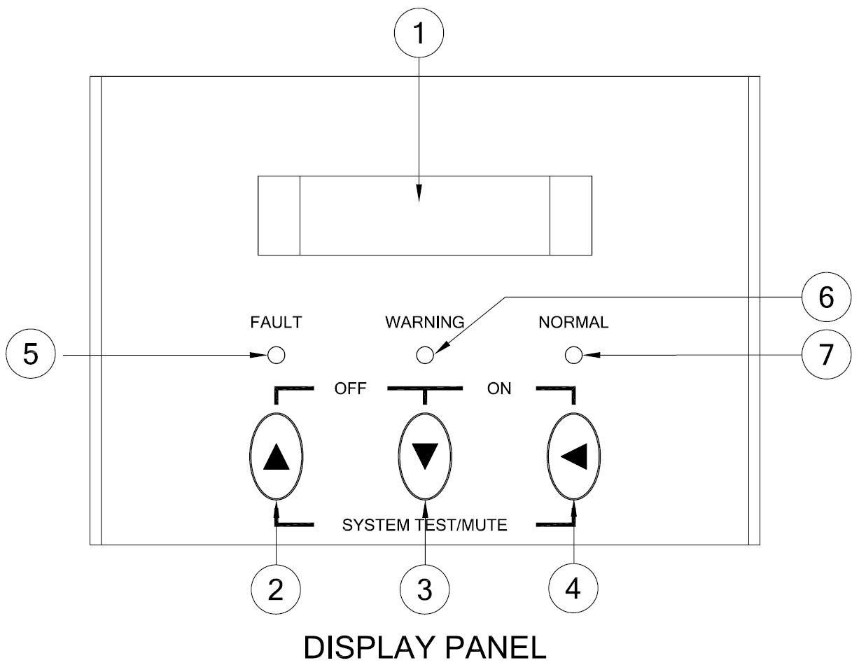

(1) LCD DISPLAY: This Indicates the UPS operation information, including UPS status, input/output voltage, input/output frequency, battery voltage, battery capacity left, output load, inside temperature, and the times of history events. Besides, UPS output voltage and output frequency can be set from the LCD panel.
(2) KEY SELECT UP: It is pressed to select upward the UPS status on LCD Display. When this key is pressed with the LCD Select Down-key simultaneously for 3 seconds, the UPS will be switched off.

(3) KEY SELECT DOWN: It is pressed to select downward the UPS status on LCD Display.

(4) KEY ON-OFF CONTROL (only available during maintenance and or repair): When this key is pressed with the LCD Select Down-Key simultaneously for 3 seconds, the UPS will be switched on. Besides, in the mode of battery back-up, press both of this key and LCD Select UP-key at the same time to disable the beeps.
(5) FAULT LED: This red LED indicates the UPS is in fault condition because of inverter abnormal or over-temperature or DC_BUS fault.
(6) WARNING LED: This yellow LED indicates the UPS is the status of overload, bypass or battery back-up.
(7) NORMAL LED: This green LED indicates the UPS is operating normally.
- OPTIONS:

- Norm ON C.B options: Unit shall provide up to 12 optional 1 pole 20amp din-rail output circuit breakers.

- Norm OFF or Norm ON W/delay C.B options: Unit shall provide up to 12 Normally OFF or Normally ON with time delay din rail Circuit Breakers.

- MBS (Maintenance by-pass manual).

- Communication interface: Unit shall have RS232 and USP communication port Option.

- SNMP/Web Card: SNMP shall allow direct monitoring in SNMP based networks for monitoring of the Unit through web browser.

- External Auxiliary TVSS: Input Transient voltage suppressor shall comply with UL1449 third edition.

- Remote status panel (AS400C W/ RELAY CARD & REMOTE MONITOR).

- Floor mount brackets: Unit shall be floor mountable.

- RS232.

- Battery Exerciser and event logger: Unit shall provide battery testing to comply
with UL924.

- Thermal runaway control by shutting of charger: Unit shall provide a
“BATT OVER TEMP” alarm.

- SPECIFICATIONS:
Specifications for 120VVAC /277VAC
Capacity (W) | Description | 500 | 750 | 1000 | 1250 | 1500 | 2100
Input | Voltage | Single Phase 120Vac or 277Vac
Input | Voltage Range | 120Vac ±10% or or 277Vac
Input | Frequency | 60Hz +/- 4Hz
Output | Voltage (on battery) | Single Phase 120Vac or 277Vac
Output | Voltage Range | 120Vac ±2% or 277Vac
Output | Frequency (on battery) | 60 Hz +/-0.5%
Output | Transfer Time | 0 ms
Output | Overload Recovery | Auto transfer to UPS
Output | High Efficiency mode (AC to AC) | > 95 %
Output | UPS Design Technology | On-Line / Fully digitized microprocessor controlled
Output | Output Wave Form | Sine wave
Output | Harmonic distortion | < 3% of T.H.D. at linear load
Protection and Filtering | Overload Protection | 125% for 1 minutes and 150% for 10 seconds
Protection and Filtering | Short Circuit Protection | Circuit breaker
System/Display/ Warning | Visual Display  (LED model) | UPS on(green), line-mode(green),  battery mode(yellow), bypass(yellow), fault(red)
System/Display/ Warning | Visual Display  (LCD model) | Input / output voltage, input / output frequency,  on-line mode, back up mode, battery capacity, load level
System/Display/ Warning | Audible Alarm  (Battery back-up) | Beep every 5 sec
System/Display/ Warning | UPS Fault | Continuous beeping sound and LCD display
System/Display/ Warning | Communication | RS-232 Serial Port and USB
Battery | 90 min. UL924 (Sealed, maintenance free lead acid battery | 8X26 A/H | 8X35 A/H | 8X35 A/H | 8X50 A/H | 8X65 A/H | 8X65A/H
Dimensions | (Inches) Width x Height x Depth | 23.5 X 34.25 X 18.25
Environmental | Operating Temperature | 0 - 40ºC / 32 ~ 104ºF
Environmental | Storage Temperature | -20 ~ 50ºC / -4 ~ 122ºF
Environmental | Audible Noise  (1 meter from surface) | < 40 dBA
Environmental | Relative Humidity | 0 ~ 95% humidity, non-condensing
Note: Due to continuous improvement specifications are subject to change without prior notice

Floor Mount Lighting Inverter
90 minute battery backup
Total/ WATT | Model Numbers | Input/Output Voltages | BTU/ Hr | Cabinet Dimension (W”xH”xD”)
 | VS.50A0100N1-S | 120V/120V | 478 | 23.5x34.25x18.25
500W | VS.50R0100T1-S | 277V/120V | 550 | 23.5x34.25x18.25
 | VS.50R2500T1-S | 277V/277V | 550 | 23.5x34.25x18.25
 | VS.50A2500T1-S | 120V/277V | 550 | 23.5x34.25x18.25
750W | VS.75A0100N1-S | 120V/120V | 492 | “
750W | VS.75R0100T1-S | 277V/120V | 575 | “
750W | VS.75R2500T1-S | 277V/277V | 575 | “
750W | VS.75A2500T1-S | 120V/277V | 575 | “
1000W | VS1.0A0100N1-S | 120V/120V | 615 | “
1000W | VS1.0R0100T1-S | 277V/120V | 675 | “
1000W | VS1.0R2500T1-S | 277V/277V | 675 | “
1000W | VS1.0A2500T1-S | 120V/277V | 675 | “
1250W | VS1.2A0100N1-S | 120V/120V | 780 | “
1250W | VS1.2R0100T1-S | 277V/120V | 890 | “
1250W | VS1.2R2500T1-S | 277V/277V | 890 | “
1250W | VS1.2A2500T1-S | 120V/277V | 890 | “
1500W | VS1.5A0100N1-S | 120V/120V | 925 | “
1500W | VS1.5R0100T1-S | 277V/120V | 1100 | “
1500W | VS1.5R2500T1-S | 277V/277V | 1100 | “
1500W | VS1.5A2500T1-S | 120V/277V | 1100 | “
2100W | VS2.1A0100N1-S | 120V/120V | 1175 | “
2100W | VS2.1R0100T1-S | 277V/120V | 1525 | “
2100W | VS2.1R2500T1-S | 277V/277V | 1525 | “
2100W | VS2.1A2500T1-S | 120V/277V | 1525 | “
(NOTE)
** BTU/HR ARE APROX. NUMBER WITH TOLERANCE ± 15% FOR ALL MODELS

